👉 Network protocols and their working

WHAT YOU WILL LEARN………………….

1. What is Network Protocols?
2. Types of Protocols.
3. How TCP works?
4. TCP Three-way Handshake.
5. TCP Vs UDP.

*1) What is Network Protocols?

=> Network protocols are a set of rules and conventions that allow electronic devices to communicate with each other over a network. These protocols define how data is transmitted, received, and processed in a network. They ensure that devices from different manufacturers can work together and that data is transferred accurately and efficiently.

*2) Types of Protocols.

=> 1. Communication Protocols
- HTTP (HyperText Transfer Protocol):
  - Function: Transfers web pages and resources from a web server to a browser.
  - Example: When you type a URL in your browser, HTTP is used to fetch the webpage from the server.
- HTTPS (HTTP Secure):
  - Function: An encrypted version of HTTP for secure communication.
  - Example: Used for online banking and shopping sites to protect sensitive information.
- FTP (File Transfer Protocol):
  - Function: Transfers files between computers.
  - Example: Used by web developers to upload files to a web server.
- SMTP (Simple Mail Transfer Protocol):
  - Function: Sends emails.
  - Example: Used by email services like Gmail to send your emails to the recipient's mail server.
- POP3 (Post Office Protocol 3):
  - Function: Retrieves emails from a mail server to a local client.
  - Example: Downloads emails to your device and usually deletes them from the server.
- IMAP (Internet Message Access Protocol):
  - Function: Accesses and manages emails on a mail server.
  - Example: Allows you to read emails from multiple devices, keeping them - -- synchronized.

2. Transport Protocols
- TCP (Transmission Control Protocol):
  - Function: Ensures reliable, ordered, and error-checked data delivery.
  - Example: Used in applications like web browsers and email clients where data integrity is crucial.
- UDP (User Datagram Protocol):
  - Function: Provides a simpler, connectionless communication without guaranteeing delivery.
  - Example: Used in streaming services and online gaming where speed is more critical than reliability.

3. Network Management Protocols
- SNMP (Simple Network Management Protocol):
  - Function: Manages and monitors network devices.
  - Example: Used by network administrators to track performance and detect issues in routers and switches.
- ICMP (Internet Control Message Protocol):
  - Function: Sends error messages and operational information.
  - Example: The "ping" command uses ICMP to test connectivity between devices.

4. Routing Protocols
- BGP (Border Gateway Protocol):
  - Function: Exchanges routing information between different networks.
  - Example: Helps ISPs and large organizations determine the best paths for data across the internet.
- OSPF (Open Shortest Path First):
  - Function: Routes data within a single IP network.
  - Example: Commonly used within large enterprise networks to manage internal traffic.

5. Security Protocols
- SSL/TLS (Secure Sockets Layer / Transport Layer Security):
  - Function: Secures communications over a computer network.
  - Example: Used to secure transactions on e-commerce websites.
- IPsec (Internet Protocol Security):
  - Function: Secures IP communications by authenticating and encrypting each IP packet.
  - Example: Used in VPNs to secure data transmission over the internet.
- SSH (Secure Shell):
  - Function: Provides a secure channel over an unsecured network.
  - Example: Used by system administrators to remotely manage servers securely.

6. Session Protocols
- PPTP (Point-to-Point Tunneling Protocol):
  - Function: Creates VPNs.
  - Example: Used to connect remote employees to a corporate network.
- L2TP (Layer 2 Tunneling Protocol):
  - Function: Combines features of PPTP and L2F for VPN support.
  - Example: Often used in conjunction with IPsec for secure VPN connections.

7. File Transfer Protocols
- SFTP (SSH File Transfer Protocol):
  - Function: Provides secure file access, transfer, and management.
  - Example: Used by developers to securely upload files to a server.
- TFTP (Trivial File Transfer Protocol):
  - Function: A simpler, lockstep FTP for basic file transfers.
  - Example: Often used for transferring firmware updates to network devices.

8. Address Resolution Protocols
- ARP (Address Resolution Protocol):
  - Function: Maps an IP address to a physical machine (MAC) address in a local network.
  - Example: Ensures data packets are sent to the correct hardware address within a LAN.
- RARP (Reverse Address Resolution Protocol):
  - Function: Maps a physical machine address to an IP address.
  - Example: Used by diskless workstations to determine their IP address upon booting.

9. Dynamic Host Configuration Protocols
- DHCP (Dynamic Host Configuration Protocol):
  - Function: Automatically assigns IP addresses to devices on a network.
  - Example: When you connect to a Wi-Fi network, DHCP assigns your device an IP address.

10. Directory Services Protocols
- LDAP (Lightweight Directory Access Protocol):
  - Function: Accesses and maintains distributed directory information services.
  - Example: Used for user authentication and directory services in organizations (e.g., Microsoft's Active Directory).

IMAGE UNDERSTANDING VIEW……….

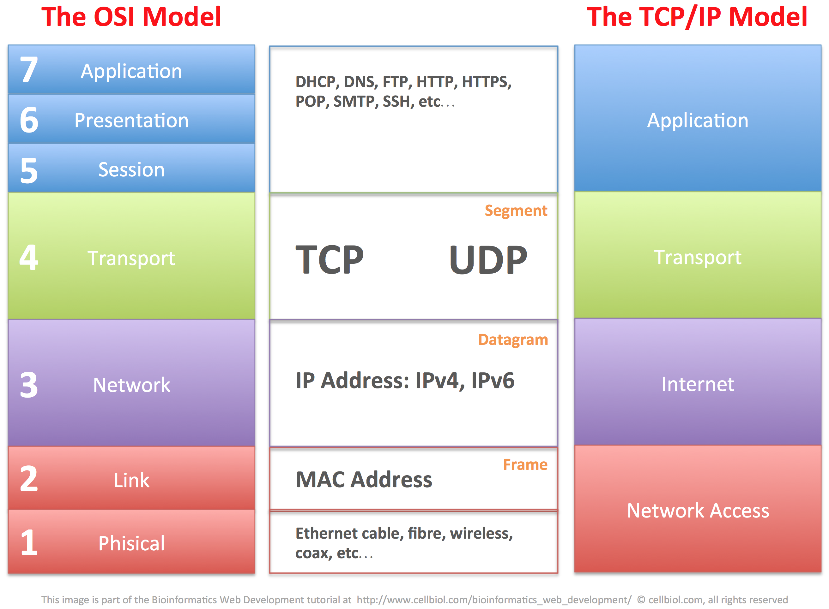

*3) How TCP works?

=> Transmission Control Protocol (TCP) is one of the core protocols of the Internet Protocol (IP) suite, commonly known as TCP/IP. It provides reliable, ordered, and error-checked delivery of data between applications running on hosts communicating via an IP network. Here's a detailed look at how TCP works:

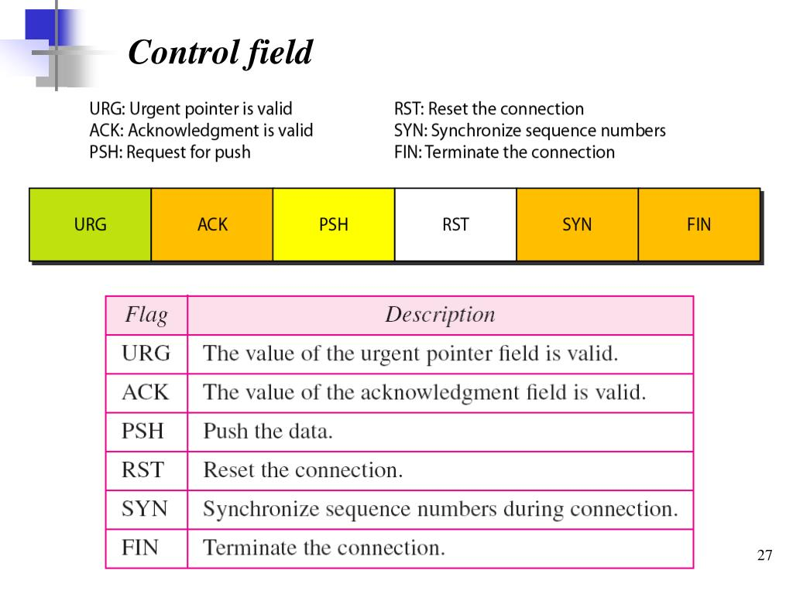

Detal …………..

- SYN (Synchronize):
  - Used to initiate a connection between two hosts.
  - During the three-way handshake, the initial SYN packet synchronizes sequence numbers between hosts.
  - Example: Client sends a SYN packet to the server to start the connection.
- ACK (Acknowledgment):
  - Indicates that the receiver has successfully received the previous packet.
  - The acknowledgment number field in the TCP header indicates the next expected byte.
  - Example: After receiving data, the receiver sends an ACK to acknowledge the receipt.
- FIN (Finish):
  - Signals the sender’s intent to terminate the connection.
  - Both sides of the connection must send a FIN to close the connection (four-way handshake).
  - Example: When a client has finished sending data, it sends a FIN packet to the server.
- RST (Reset):
  - Abruptly terminates an existing connection.
  - Used to indicate that something went wrong, and the connection needs to be reset.
  - Example: If a host receives a packet for a closed or non-existent connection, it may send an RST.
- PSH (Push):
  - Indicates that the data should be pushed to the receiving application immediately.
  - The receiver should process the data immediately rather than buffering it.
  - Example: Used in interactive applications like Telnet or SSH where immediate data transfer is necessary.
- URG (Urgent):
  - Signifies that the data contained in the packet is urgent.
  - The urgent pointer field in the TCP header specifies the position of the urgent data.
  - Example: Used for sending priority data that needs immediate attention.
- ECE (ECN-Echo):
  - Part of Explicit Congestion Notification (ECN) used for network congestion control.
  - Indicates that the TCP peer is ECN-capable and can handle ECN-related information.
  - Example: When a packet with ECN-Capable Transport is received with congestion experienced, the receiver sets the ECE flag in its ACK.
- CWR (Congestion Window Reduced):
  - Used in conjunction with the ECE flag for ECN.
  - Indicates that the sender has reduced its congestion window.
  - Example: When the sender reduces its transmission rate due to congestion, it sets the CWR flag to acknowledge the ECE signal.
- NS (Nonce Sum):
  - Used for protection against accidental loss of data and TCP spoofing.
  - Helps ensure the integrity of the ECN-related information.
  - Example: Part of the ECN nonce enhancement used to detect and prevent malicious attempts to tamper with ECN signals.

TCP Flag Combinations and Use Cases
- SYN: Initiates a connection. Only the SYN flag is set.
- SYN-ACK: Acknowledges a SYN request and synchronizes sequence numbers. Both SYN and ACK flags are set.
- FIN-ACK: Acknowledges the termination of a connection. Both FIN and ACK flags are set.
- PSH-ACK: Pushes data to the receiving application and acknowledges the receipt of data. Both PSH and ACK flags are set.
- URG-ACK: Indicates that urgent data is included and acknowledges receipt. Both URG and ACK flags are set.

Three-Way Handshake
- SYN: Client → Server (Client sends a SYN packet with a sequence number).
- SYN-ACK: Server → Client (Server responds with a SYN-ACK packet, acknowledging the client's SYN and providing its own sequence number).
- ACK: Client → Server (Client sends an ACK packet, acknowledging the server's SYN-ACK).
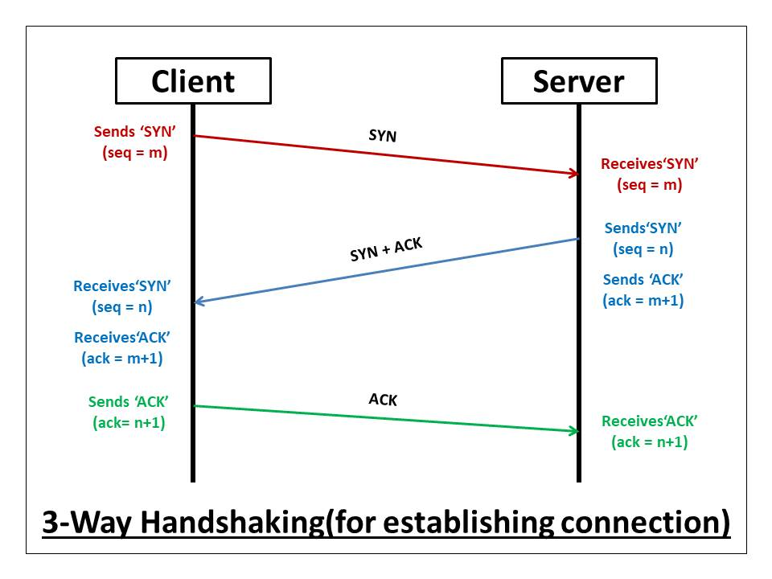

Connection Termination (Four-Way Handshake)

Example: Connection Termination (Four-Way Handshake)
- FIN: Client → Server (Client sends a FIN packet to close the connection).
- ACK: Server → Client (Server acknowledges the client's FIN).
- FIN: Server → Client (Server sends its own FIN to close the connection).
- ACK: Client → Server (Client acknowledges the server's FIN).
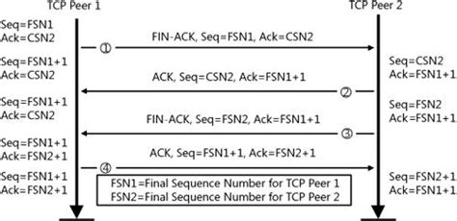

*5) TCP Vs UDP?

=> Transmission Control Protocol (TCP) and User Datagram Protocol (UDP) are two of the most fundamental protocols in the Internet Protocol (IP) suite. They serve different purposes and have distinct characteristics. Here's a detailed comparison of TCP and UDP:

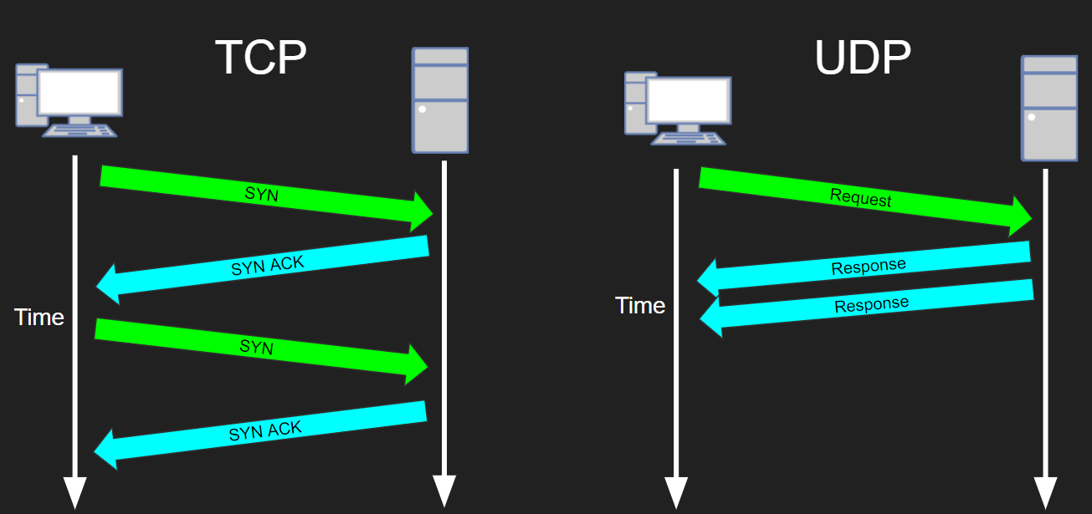

By RAJ…

